Promoted for and on behalf of Cycling Time Trials
under their Rules and Regulations
Farnborough & Camberley CC
Open 25 Mile Time Trial
Saturday 09th April 2022 At 1600 Hours
(sign on from 1500 hours)
EVENT SECRETARY: Gavin Watson
2 Harvey Road
Farnborough
Hampshire
Tel: 01252 668685 or 07958442501 Email: BIkeswimcoachwatson@gmail.com
TIMEKEEPERS: Donald Ashton (Farnborough & Camberley CC)
Christina Gustafson (Reading CC)
HEADQUARTERS: Bentley Memorial Hall, Hole Lane, Bentley GU10 5NB

- COVID update – No Covid restrictions but if you have symptoms please don’t attend. Please follow government guidelines.

- Refreshments will be available please bring change to contribute to cost

- FRONT & REAR LIGHTS AND HELMET ARE NOW COMPULSORY – Cycling Time Trials Regulation:

#14(i) states “No competitor shall be permitted to start either a Type A or Type B event unless such competitor has affixed to the rear of their machine a working rear red light, either flashing or constant, that is illuminated and in a position that is clearly visible to other road users.”

14j. No competitor shall be permitted to start either a Type A or Type B event unless such competitor has affixed to the front of their machine a working front white light, either flashing or constant, that is illuminated and in a position that is clearly visible to other road users.

15. All competitors must wear a properly affixed helmet which must be of hard/soft shell construction. Helmets should conform to a recognised Standard such as SNELL B95, ANSI Z90.4, AUS/NZS 2063:96, DIN 33-954, CPSC or EN 1078. It is the responsibility of the rider to:
Select a helmet that offers protection against head injury and does not restrict the rider's vision or hearing.
Ensure that the helmet is properly fitted, is undamaged and in good condition.
Footnotes:
(i) Any helmet which suffers damage (e.g. in the case of an accident or through mishandling) may no longer afford the same level of protection.
(ii) Cycling Time Trials makes no warranties or representations regarding the adequacy of any standard or the fitness for the purpose of any brand of helmet and will not accept any claims arising from the use of any particular helmet.
(iii) The current British Standard BS 6863 is primarily intended for use by young riders and is not intended to provide a complete specification for helmets for high speed or long distance riding.

- Please respect the local residents of Bentley by parking considerately. Do not park on the road near the headquarters, even for a short period of time. Please adhere to the guidance on the parking notes and diagram included below. If we receive complaints, we may lose Bentley Memorial Hall as an option for the HQ. This could potentially mean the end of up to 20 open events on the course during the year.

- Please respect the volunteers from Farnborough & Camberley CC and the timekeepers who are giving up their time to help out.

- Please sign on and collect your numbers from the headquarters.

- NO TURBOS ARE TO BE USED IN THE VILLAGE. Warm ups to be done riding on the road or using Turbos in the Bull Inn layby. Any garments left at the start line for collection later are at your own risk and will not be handled by Race Staff.

- Position your number so that it is visible from the rear when in the racing position. Reg 16.

- This event may be subject to a Doping Control - It is your responsibility to check by returning to the HQ and signing out as soon as possible after you finish.
A rider who fails to sign the official signing-out sheet shall be recorded as DNF - CTT Regulation #17(b)

- Please return your numbers to HQ when you sign out, where refreshments can be found after completing the event.

- No cleats or bikes are allowed in the hall.

- Please allow at least 10 minutes to get to the start.

- The start is on the opposite side of the carriageway from the HQ. Riders should only use designated crossing points and must not climb over the central reservation. Anyone seen doing so will be disqualified from the event.

- Head-down riding kills – if dangerous riding is witnessed it will be investigated and reported.

- No vehicles, except those of the timekeepers and event volunteers, shall be parked at the start or finish

- For safety reasons riders must not use their aero bars on the Coxbridge roundabout, the penalty is
disqualification. The approach and exit have been resurfaced, (Yay!), making it a slightly safer ride now.

- There are some Juniors competing, can they bring the completed Parent/Guardian Permission form with them when they sign in.

CAR PARKING

Car parking is available at the HQ and in the lay-bys past the finishing point as highlighted in green in the map below.
DO NOT park in the areas highlighted in red in the map below and if parking in River Road please ensure you only park on the grass verge, keeping the footpath and bus stop clear. As stated below do not park on the eastern side of River Road between Main Road and the bridge over the A31.

Map below.
DO NOT park in the areas highlighted in red in the map below and if parking in River Road please ensure you
only park on the grass verge, keeping the footpath and bus stop clear. As stated below do not park on the
eastern side of River Road between Main Road and the bridge over the A31

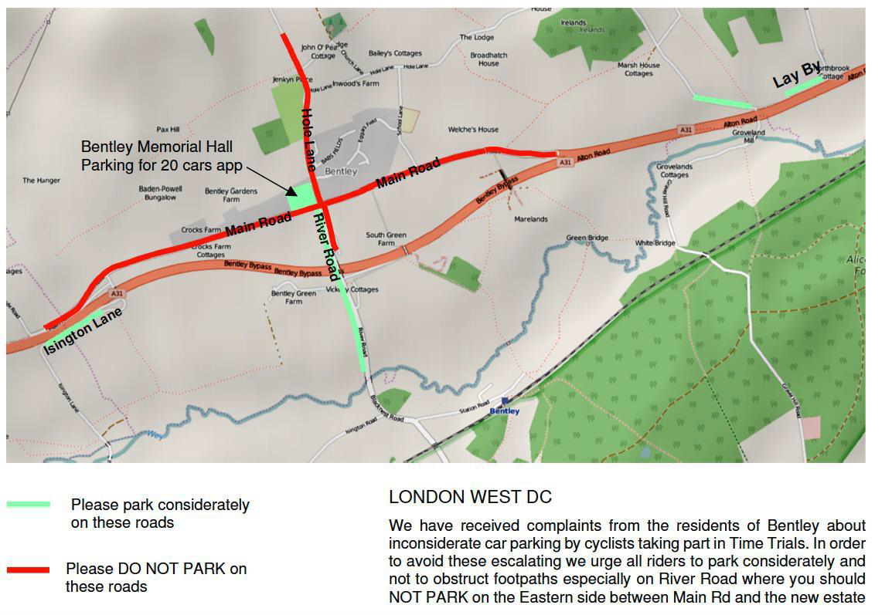

DIRECTIONS TO THE START
To reach the start from the HQ in Bentley, go eastwards through the village to join the A31, cross to the right
hand lane after 850 yards (there are lane marking s) and then cross over to the South side of the A31 at the
Gravel Hill road junction just short of the ‘Bull’ PH and continue westwards for 760 yards to the lay by start
Point.
IN THE INTERESTS OF YOUR OWN SAFETY

Cycling Time Trials and the event promoters strongly advise you to wear a HARD SHELL HELMET that meets an internationally accepted safety standard.

There will be marshals and checkers but it is your responsibility to make sure you know the course.

PRIZES
1st Fastest Male £25 2nd Fastest Male £20 3rd Fastest Male £15
1st Fastest Female £25 2nd Fastest Female £20 3rd Fastest Female £15
1st Fastest Vet on Std £20 2nd Fastest Vet on Std £15 3rd Fastest Vet on Std £10
1st Junior/novice award Male £15 1st Junior/novice award Female £15
Laterne Rouge £10
Fastest Tandem £10

Course Detail follow link below
https://www.cyclingtimetrials.org.uk/race-details/23460

